Submitting an application for a COVID-19 medical device: Interim Order

Name of the Device
Aerosol-Reducing Mask for use with BiPAP and CPAP machines

Class of the Device
Class II

Identifier of the Device
Model No.: 004

Manufacturer information
Glia Inc.
54 Craig Street
London, ON N6C 1E8

Intended use of the device
The intended purpose of the Aerosol-Reducing Mask for use with BiPAP and CPAP machines is to allow the use of non-invasive positive pressure ventilation (NIPPV) machines for patients in need of positive pressure ventilation. It is intended for use in emergency rooms, intensive care units, prehospital transport, intra- and inter-hospital transport, and for emergency use in remote health stations without access to assisted ventilation systems. This device may be used any time infection control is a concern, including with patients who have COVID-19 or those who may be at risk of an aerosol-borne disease such as COVID-19, influenza, or other viruses.
A major challenge associated with COVID-19 is the demand it places on the use of invasive ventilators. Traditional non-invasive ventilation strategies, such as Continuous Positive Airway Pressure (CPAP) and Bi-level Positive Airway Pressure (BiPAP), vent directly to the surounding space due to poor seal between the mask and face. Practitioners are consequently reluctant to use non-invasive ventilation due to the increased risk of spreading coronavirus to healthcare providers and patients. The Aerosol-Reducing Mask can be used to provide fully functional CPAP or BiPAP ventilation while significantly decreasing the level of aerosolization, thus reducing the risk of infection to others.

Quality, Safety and Effectiveness information
The quality, safety, and effectiveness of the Aerosol-Reducing Mask has been extensively tested in pre-deployment human factors evaluation. Glia has collaborated with Western University, University of Toronto, London Health Sciences Centre and General Dynamics Land Systems – Canada to create a safe and well-tested mask.

a. Description of device, how it works, accessories to be used, diagrams/photos
The Aerosol-Reducing Mask consists of three parts: a 3M Scott AV2000 mask, an adapter to interface it to a non-invasive ventilator with CPAP or BiPAP, and a seal gasket. This device will be used with:
- Continuous Positive Airway Pressure (CPAP) and Bi-Level Positive Airway Pressure (BiPAP) non-invasive ventilator which has built-in systems for controlling oxygen supplementation and managing and measuring pressures.
- Supplemental oxygen from flowmeter (either wall oxygen or oxygen concentrator).
- Either of 1 or 2, with nebulized medications
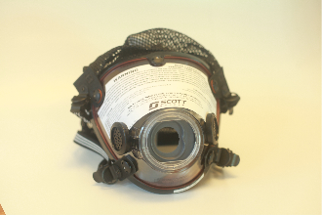
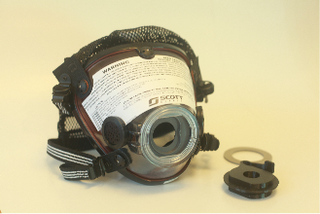
Full kit: AV 2000 mask, 3D adapter, seal gasket AV 2000 mask front view

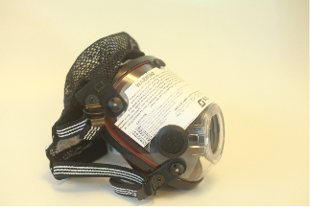
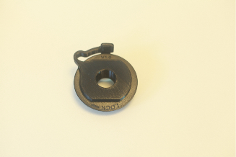
3D printed adapter AV 2000 mask side view
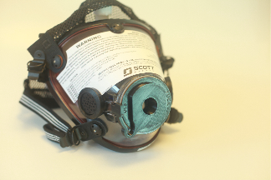
Fully assembled: Aerosol-Reducing Mask for use with
BiPAP and CPAP machines

b. QMS Certificate, evidence of Good Manufacturing Practices, or other
Glia has developed a quality management system in accordance with the policies and requirements as set out in ISO 13485 and applicable regulatory requirements. Glia minimizes risk through medical device quality management systems processes in the following ways:
- Adherence to best practices as per ISO 13485 and ISO 9001
- A Medical Device Establishment License issued by Health Canada
Glia is currently in the process of achieving ISO 13485 and MDSAP certification. While the former is possible during COVID-19 restrictions, the latter is currently suspended for all new organizations as per directives. As such, Glia will obtain both certifications at the earliest available opportunity.
Glia’s partner in this project, General Dynamics Land Systems, is providing QMS expertise and guidance as well.

c. Components manufactured using additive manufacturing
The Aerosol-Reducing Mask includes a 3D printed adapter component that is made with either ABS or PETG as both are already commonly used in medical equipment. This adapter utilizes fused filament fabrication (FFF) 3D printing technology.

d. Is device manufactured from animal or human tissue or their derivative
The device is neither manufactured from nor incorporates any animal or human tissue or their derivative.

e. Summary of any mechanical/bench testing data performed for the device
See Pages 7-10 of the attached white paper in Appendix A for further information about testing performed on the device. In this testing, Glia and General Dynamics:
- Conducted successful instrumented pressure and leak tests of 3D printed adapters to operational limits;
- Conducted successful characterization testing to quantify impact of patient coughing. Performance was deemed acceptable;
- Provided mask kit to medical team to conduct internal pilot testing with respiratory therapists (RTs) on 2 April 2020. RTs successfully tested on members of the team with different face sizes, machines, and circuit configurations with good results. Testing resulted in simplified circuit and adapter design;
- Provided four prototypes to London Health Sciences Centre (LHSC) on 4 April 2020; further protocol and pilot process testing was successfully completed. LHSC leadership provided support to continue after witnessing testing;
- Completed porosity testing on 3D printed adapters with 20%, 40%, 60%, 80%, and 100% infill;
- A smoke test was conducted in which smoke was put into and around the mask to observe any air leak. No air leak was observed.
- Pilot testing during which members of the research team were fit-tested while wearing the mask, and supervised by respiratory therapists for mask leak at standard NIPPV pressures. Use of 5, 10, 15, 20,and 25 cm H2O pressure did not leak from the mask;
- The Aerosol-Reducing Mask was placed on standardized dummies and no leak was found, using the spectrum of standard NIPPV settings;
- A patient study will began at London Health Sciences Centre and Western University on 18 April 2020;
- Reviews were conducted by physicians and allied health professionals from respirology, emergency medicine, and critical care who observed the Aerosol-Reducing Mask testing, and were universally in support of its broader use;
- Given the urgency of applying this essential technology broadly, a clinical study will be ongoing during real-life application.

f. Summary of any animal testing and clinical investigations carried out with the device
Clinical testing is ongoing and has received interim approval from the Health Sciences Research Ethics Board at University of Western Ontario and Lawson Health Research Institute in London. Appendix B shows the research protocol submitted for this study. The study will be ongoing post device release and is already showing encouraging data.

g. Summary of any biocompatibility testing performed with the device
No specific biocompatibility testing has been conducted.

h. Summary of evidence of shelf-life and packaging validation
The shelf life of the device without maintenance is 5 years. This is based on the wear time of the rubber seals in the 3M seal gasket and 3M Scott AV2000. The plastic in the 3M Scott AV2000 mask, the 3M seal gasket and the adapter have a shelf year of at least 10 years.
If maintained and greased regularly, the rubber in the mask and gaskets should last indefinitely.

i. Summary of electrical safety and electromagnetic compatibility
This device has no electrical or electronic components. The device has metal latches and is not approved for use with MRI.

j. If device intended to be used at point of care or sold directly to a consumer; marketing materials
The Aerosol-Reducing Mask is intended to be used in emergency rooms, intensive care units, prehospital transport, intra- and inter-hospital transport, and remote nursing stations. No sales will happen to consumers or lay-people.

k. If device is intended to be sold in a sterile condition, a description of sterilization method, and summary of sterilization validation testing performed
The Aerosol-Reducing Mask will not be sterile and is intended to be used in a non-sterile operating environment.

l. List of applicable standards used in design/manufacture of the device
There are no specific standards applicable to this device.
This device is manufactured in compliance with ISO 13485 and Good Manufacturing Practice regulations. General Dynamics, one of Glia’s manufacturing partners, holds an ISO 9001 license.
Currently, Glia is pursuing an ISO 13485 and MDSAP.

m. Incidents with a discussion of each event and response from the manufacturer
There have been no incidents with the device. Glia currently has a standard operating procedure for complaint handling that the corporation has employed for several years and that has recently been audited by Health Canada in 2019 December. A copy of the SOP is included in Appendix C. Appendix D is Glia’s complaint record. Should corrective action or a recall be necessary, Appendix E shows Glia’s SOP for corrective and recall action.
There have been no critical incidents to date in the use of this device. To date the device has only been deployed in pilot testing by the development team.

n. Comparison table outlining technological differences between this device and predecessors that are or were licensed in Canada
The main distinction between this device and others on the market is that this device provides a stronger seal and substantially reduces leakage. In general BiPAP masks are not sold as stand alone, and are instead sold as part of a system.

o. Comparison table outlining technological differences between the proposed Covid-19 medical device and any available (authorized) comparators
There are no authorized masks related to the Covid-19 pandemic that substantially reduce aerosolization and leakage.

p. If the medical device is, or includes software
The device is not, nor does it include, software.

q. If the medical device is, or includes, an in-vitro diagnostic devices, etc.
The device is not, nor does it include in-vitro diagnostic devices.

Directions for Use
The device will be shipped with a complete, illustrated, user guide of which the following is in an excerpt, including only the directions for use.

Mask Fit-Up and Use
WARNING

Appropriate personal protective equipment must be worn for entire procedure.

- Select mask size using ErgoFitTM Headgear Sizer.

NOTE

Ensure seal on mask adapter is not damaged. If damaged, remove using sharp knife or scraper. Replace with new seal.

WARNING

Ensure all connections are tight and secure to prevent air leaks.

- Insert mask adapter into front of mask and tighten until locked into position.
- Insert DAR filter into port on mask adapter.
- Loosen straps on mask harness and place mask on patient.

WARNING

Ensure mask is properly fitted and sealed to prevent any leaks. Ensure all connections are tight and secure to prevent air leaks.

- Ensure proper mask fit over mouth and nose and on face.
- Tighten straps of mask harness to ensure tight fit of mask (2x jawline, 2x over ears).
- Use gloved hand to ensure tight seal around face. Perform leak test on mask to ensure system is sealed. Adjust, as required, until system is properly sealed.
- Place bouffant cap/hood over patients head.
- Connect elbow fitting to DAR filter.
- Connect whisper valve to elbow fitting.
- Connect 22mm air hose to whisper valve.
- Connect other end of 22mm hose to port on CPAP/BiPAP machine.
- Uncap port on DAR filter. Connect CO2 sensor hosing to port on DAR filter.
- Connect other end of CO2 sensor hosing to machine.
- Turn on CPAP/BiPAP machine as per Standard Operating Procedure (SOP).

Filter Change Procedure
WARNING

Appropriate personal protective equipment must be worn for entire procedure.

WARNING

Ensure CPAP/BiPAP machine is turned off and all residual pressure has been released from system before changing filter or removing mask to prevent releasing aerosolized virus.

- Turn off CPAP/BiPAP machine as per Standard Operating Procedure (SOP).
- Ensure all residual pressure has been released from system.
- Remove DAR filter from mask adapter.
- Remove DAR filter from elbow fitting. Consider the DAR filter contaminated. Discard as per contaminated waste protocols.
- Insert new DAR filter into port on mask adapter.
- Connect elbow fitting to DAR filter.
- Perform leak test on mask to ensure system is sealed. Adjust, as required, until system is properly sealed.
- Turn on CPAP/BiPAP machine as per Standard Operating Procedure (SOP).

Mask Removal
WARNING

Appropriate personal protective equipment must be worn for entire procedure.

- Disconnect elbow fitting from DAR filter.
- Turn off CPAP/BiPAP machine as per Standard Operating Procedure (SOP).
- Remove DAR filter from mask adapter. Consider the DAR filter contaminated. Discard as per contaminated waste protocols.
- Loosen mask harness and remove mask.

Mask and all connected components are considered contaminated and should be handled as per Standard Operating Procedure (SOP).

- Mark mask and components for approved decontamination protocol, as per cleaning instructions.

Attestation for Post-Market Oversight
[x] I, the Applicant, have objective evidence to establish that I have documented procedures in place with respect to distribution records, complaint handling, incident reporting and recalls. I submit this attestation in partial fulfillment of the application submission requirements of the Interim Order Respecting the Importation and Sale of Medical Devices for Use in Relation to COVID-19.

I, as a senior official of the manufacturer of this application, hereby attest that I have direct knowledge of the item checked above and declare that these identified statements are true and that the information provided in this application and in any attached documentation is accurate and complete.

Where a person is named in Item X of this application, I hereby authorize that person to submit this application to the Minister on my behalf. I further authorize the Medical Devices Directorate to direct all correspondence relating to this application to the person named in Item X of this application.

Name: Tarek Loubani
Title: President and Medical Director
Signature:


Date: 2020 April 17

Device Label
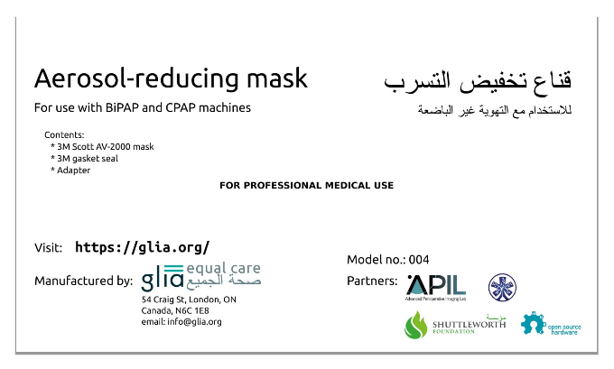

Materials
Not applicable

Marketing History
Not applicable

Foreign Regulatory Approval
Not applicable

